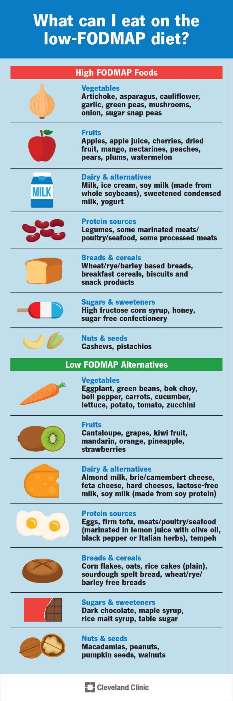
FODMAP Diet info- Fermentable Oligosaccharides, Disaccharides, Monosaccharides and Polyols.
To ease IBS and SIBO symptoms, it’s essential to avoid high FODMAP foods that aggravate the gut, including:
- Dairy-based milk, yogurt and ice cream
- Wheat-based products such as cereal, bread and crackers
- Beans and lentils
- Some vegetables, such as artichokes, asparagus, onions and garlic
- Some fruits, such as apples, cherries, pears and peaches
Instead, base your meals around low FODMAP foods such as:
- Eggs and meat
- Certain cheeses such as brie, Camembert, cheddar and feta
- Almond milk
- Grains like rice, quinoa and oats
- Vegetables like eggplant, potatoes, tomatoes, cucumbers and zucchini
- Fruits such as grapes, oranges, strawberries, blueberries and pineapple
Get a full list of FODMAP food from your doctor or nutritionist.

